Ten Tough Tips for Saving Energy in Pennsylvania

You’ve seen (and maybe done) all the easy tips for saving energy in your home. But like exercising or dieting, the easy steps only take you so far. To really make a dent in your energy bills and an impact on climate change, it takes some time and effort. This is a short list of ten things that can put you on the right path, and it’s just a start.

Keep in mind that your “house is a system”. What you do to one part affects how many other elements work. So pay close attention to Step 2 – bringing in an expert – an auditor, rater or home performance analyst who can help you get results. This list is geared to our moderately cold climate.

- Set priorities for what you want to do. Do you want to lower your bills? Or improve comfort – or both? Maybe you have moisture problems? Then do your homework. First, put together a summary of your heating and electric costs for the past year. Get copies from your utilities and heating oil companies if you don’t have them. Then analyze your bills. Make note of any moisture or air quality problems.

The Energy Star® Home Energy Star Yardstick is a good place to start (find it at www.energystar.gov/index.cfm?c=home_improvement.hm_improvement_index). You can plug in your information and get an idea of how your house compares. Many utilities now offer online bill tracking and online energy audits to help you figure out your costs, and they may even tell you if your bills are higher than average. Also find out more about saving energy before you start. Use the ENERGY STAR website, your local utility site, or your library. Or call our office for more information.

- If your house is drafty and uncomfortable or you think your bills are higher than they should be, let us perform an energy rating or audit for you. The audits range from $200 - $500, so only do this if you plan to actually take our advice. We have all the tools to show you exactly what is happening to your energy dollars. The blower door and infrared camera tell no lies.

- Be prepared to upgrade your insulation, particularly in the attic. We probably will also recommend air sealing of passages (bypasses) that leak air to the attic or to other unconditioned spaces. Older homes usually don’t have enough attic insulation. Even new homes can have gaps and poorly sealed air passages, which is where the blower door is a useful tool. Ask about dense pack and foamed-in-place insulation, which are newer techniques.

- Let us clean and tune your furnace, boiler or heat pump and test it to determine its efficiency. We use the most modern testing and adjustment equipment available. Recognize that your furnace or boiler is also part of a whole system. Think about how it is working. Let us know if you have rooms that are too hot or too cold.

If you have a furnace or heat pump, we will check the duct connections and boots, particularly if they run through unheated space, such as a crawlspace, garage or attic. We will use mastic and mesh tape, not duct tape, to seal any gaps. For boilers, we will check for air in the line or recommend that you use thermostatic radiator valves for individual rooms.

- Changing your furnace or boiler is a tough and expensive decision to make. Figuring out efficiencies and what you will save is a bit complicated. We can give you an analysis based on your recent fuel bills. If your heating equipment has a low efficiency (60 – 75%), is older than 10 years, or would cost over $500 to fix, you should replace the unit. We will calculate what size you need, not just do an estimate. We only install ENERGY STAR® qualified units. With high fuel and electric prices, the payback time is much shorter than it used to be.

- Replace inefficient appliances. Older refrigerators and electric water heaters use the most energy. Replace any refrigerator that is older than 15 years with an ENERGY STAR model. Choose a smaller model and consider if you really need an icemaker or in-door water supply. Get rid of second refrigerators and freezers, particularly refrigerators that are older models. To determine if your refrigerator needs to be replaced for energy saving reasons, go to www.energystar.gov/ , click on appliances and then click on Refrigerator Retirement. Look for information on other energy efficient appliances, such as dish washers, on this site as well.

- Check for and repair all plumbing leaks. You’re wasting not only water, but also your electricity, gas, or oil for any hot water leaks. Turn the temperature on the water heater down to 120 F degrees. Insulate pipes that run through unheated spaces.

- Buy a front-loading ENERGY STAR qualified clothes washer, particularly if you do 3 or more loads a day, have high water bills, or have experienced water shortages.

- Unplug or shut-off anything you are not using. TV’s, DVR’s, entertainment centers, computers, printers and battery chargers all draw a small amount of energy even when they are off. Plug these into power strips that you can shut off easily. It does not hurt the equipment to do this.

We have a “Watt Meter” that measures the energy use of this equipment and anything else you run all the time. We can show you how to determine the cost of operation of your appliances or you can purchase a wattmeter for your own use. Dehumidifiers, hot tubs and aquariums are real energy hogs.

- Choose behaviors that reflect your priorities. Think about how you use energy. Turn off equipment and lights. Set back your thermostat at night and when you are away. Wear warmer clothes.

Thank you for doing your part.
Let us know if you need help and also, let us know how you do!

Field’s Service, Inc.

Resources:

Michael Blasnik, “Energy Conservation: What Are My Choices? What Can I Save?”, presented at National Low-Income Energy Conference, Nashville, TN, June 5, 2007. www.nliec.org/2007%20Conference/2007_Presentations.htm

Chicago, Department of Environment, Heating Systems, http://webapps.cityofchicago.org/ERC/tips.htm

Energy Star® Home Energy Star Yardstick, www.energystar.gov/index.cfm?c=home_improvement.hm_improvement_index

Home Energy magazine, www.homeenergy.org/ . Check under the DIY section.

To find out more about home performance and how to select and locate energy auditors, raters and home performance contractors, check the ACI website: www.affordablecomfort.org .

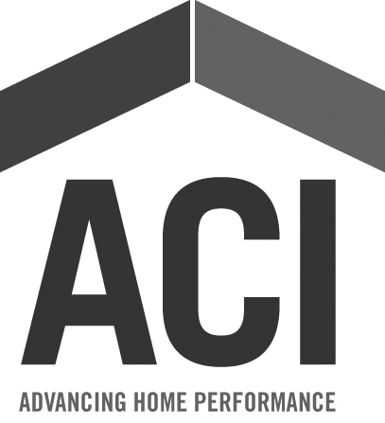

Keystone
Energy Efficiency
Alliance (KEEA)
Ask First About
Saving Energy

